|  |
| --- |
|  |
| DESCRIPTIVE ANALYSIS & VISUALIZATION OF REAL DATA:  “A STUDY ON CHENNAI WATER CRISIS” |
| |  |  |  | | --- | --- | --- | | Mandeep Kumar | 7/21/19 | PGCBA -2 | |

Contents

Section1: Introduction 2

Section2: Description of the data 3

Section 3: Analysis & Visualization 4

1. Summary of rainfall data: 4

2. Summary of Water level of reservoirs 6

3. Is water level of reservoirs related to rain waterfall? 7

4. Can we categorize the season for the Chennai city? 8

5. Average consumption by the city? 9

6. Was year 2004 also a crisis situation? 11

7. Is it really a water crisis in the year 2019? 12

8. What is probability that rainfall will be below average in the year 2019? 13

9. Water Level forecast: 14

10. Rainfall prediction for 2020 and 2021: 15

Section 4: Conclusion 16

# Section1: Brief description of the field of the study

In the month of Jun-2019, the news of Chennai Water Crisis hit all types of media with red alert with the magnitude never before. The situation is similar in most of the Indian cities. As per some articles 40 Indian cities will run out of water supply by 2026. The concept of Day ZERO originated from Cape Town is all scary and nightmare about to knock the door in everyone’s life. This triggered curiosity in me to look into the water situation closely. Few decades back Chennai used to have surplus water than needed and lot more water supply bodies. But now main source has been limited to 4 water bodies and underground water. This is mainly because of rapid urbanization of the city that must have led to encroachment to water bodies.

The dataset in this report has been taken from website <https://www.kaggle.com/>. One of the contributor of the website has collected the main Chennai water reservoir levels and rainfall over those reservoirs and made it public for study.

# Section2: Brief description of the data

The city of Chennai is currently dependent on following 4 water reservoirs –

1. Chembarambakkam
2. Cholavaram
3. Poondi
4. Redhills

In this dataset water level of each reservoir is provided for each day in the unit million cubic feet (mcft). There is another complementary data set collected alongside that contains rainfall over above water bodies in mm (millimeter).

The link for the dataset is : [https://www.kaggle.com/sudalairajkumar/chennai-water-management](https://www.kaggle.com/sudalairajkumar/chennai-water-management#chennai_reservoir_rainfall.csv)

Explanation of dataset with name “chennai_reservoir_levels.csv”: This contains column with names

* Poondi: This records the water level for Poondi reservoirs in the unit mcft.
* Cholavaram: This records the water level for Cholavaram reservoirs in the unit mcft.
* Redhills: This records the water level for Redhills reservoirs in the unit mcft.
* Chembarambakkam: This records the water level for Chembarambakkam reservoirs in the unit mcft.

Explanation of dataset with name “chennai_reservoir_rainfall”: This contains column with names

* Poondi: This records the rainfall over Poondi reservoirs in the unit mm.
* Cholavaram: This records the rainfall over Cholavaram reservoirs in the unit mm.
* Redhills: This records the rainfall over Redhills reservoirs in the unit mm.
* Chembarambakkam: This records the rainfall over Chembarambakkam reservoirs in the unit mm.

# Section 3: Analysis & Visualization

## Summary of rainfall data:

|  |  |
| --- | --- |
| SUM(Total Rainfall) | Unit = mm |
| Sum | 82,758 |
| Average | 5,517 |
| Minimum | 3,367 |
| Maximum | 9,108 |
| Median | 5,181 |
| Standard deviation | 1,721 |
| Skewness | 0.91 |
| Excess Kurtosis | 0.02 (Leptokurtic) |

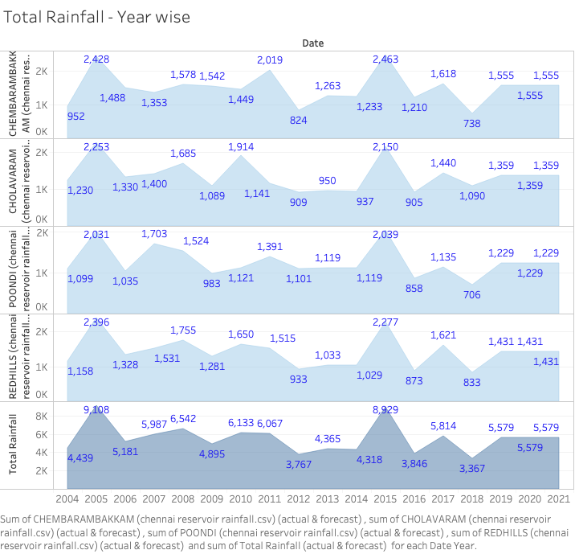

## Summary of Water level of reservoirs

|  |  |
| --- | --- |
| AVG(Total Water level) |  |
| Sum | 66,272 |
| Average | 4,142 |
| Minimum | 386 |
| Maximum | 7,964 |
| Median | 3,754 |
| Standard deviation | 2,364 |
| Skewness | -0.05 |
| Excess Kurtosis | -1.24 |

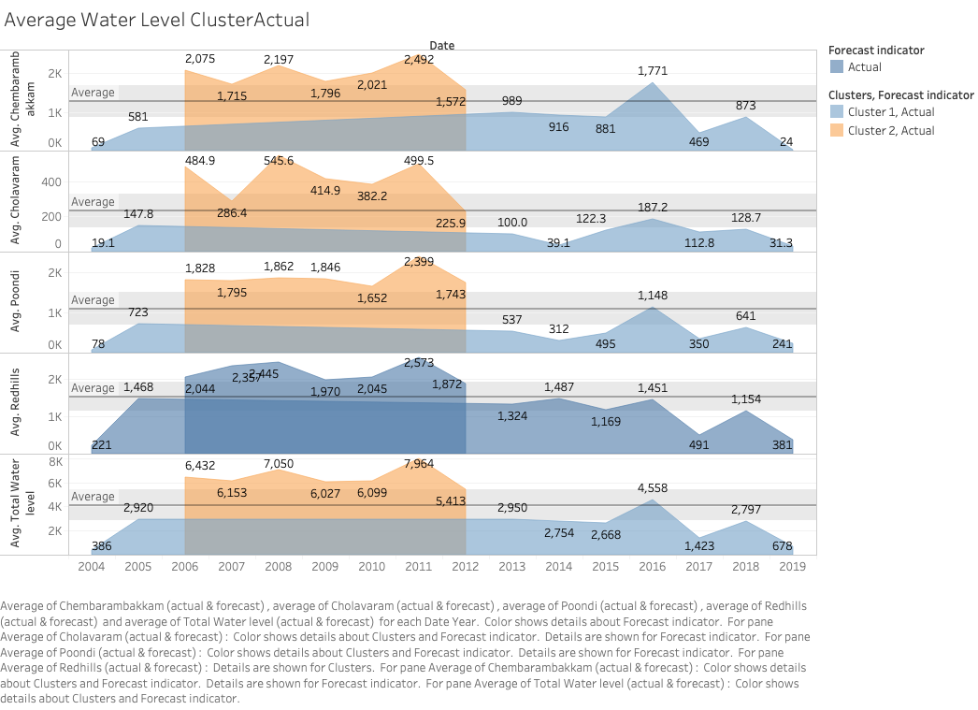

## Is water level of reservoirs related to rain waterfall?

After observing the Rainfall Vs Water level plot, it indicates that water level increases in case of good amount of rainfall. The amount of increase seems to be varying, however that could be because of increasing water consumption by the city of the period of years specially after year 2011.

Note: The plot below is big, so it may need to zoom it for proper view.

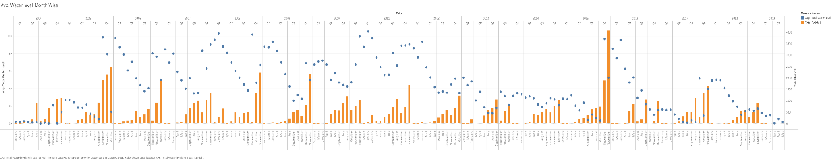

## Can we categorize the season for the Chennai city?

From the above plot (in #3), it is clear that the we can categorize season for the city into 3 categories -

1. Monsoon: Q4 (Oct-Nov-Dec) is the quarter when city receives the maximum rainfall.
2. Regular: Q3 (Jul-Aug-Sep) is the quarter when city receives some rainfall.
3. Dry: Q1 (Jan-Feb-Mar) and Q2 (Apr-May-Jun) are the quarters when city receives no rainfall.

## Average consumption by the city?

|  |  |
| --- | --- |
| Difference in AVG(Total Water level) |  |
| Sum | -214 |
| Average | -1 |
| Minimum | -1,375 |
| Maximum | 6,604 |
| Median | -230 |
| Standard deviation | 1,112 |
| Skewness | 2.53 |
| Excess Kurtosis | 9.27 |

If we observe change of average water level against the previous month when there is no rainfall, then we can say that the amount of water is either consumed by the city or evaporated. In either situation it is good indication for need of water level to serve the city. The Positive change in the water level is good and can be ignored in this question. So here Median parameter would be a good indicator.

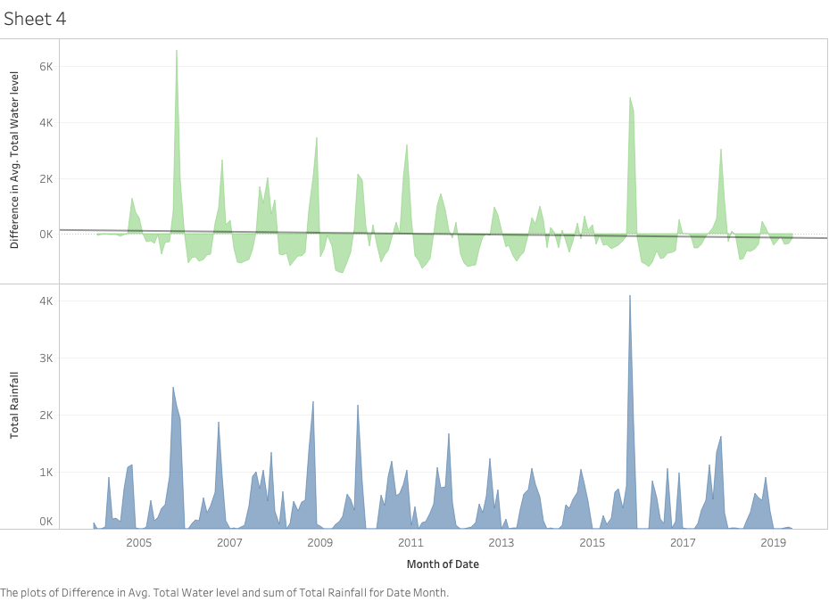

## Was year 2004 also a crisis situation?

There must have been crisis situation. Approximately 230 mcft change in water we have observed when there is no rainfall. There were 276 days out of 265 days in the year when the total water level was observed <= 230 mcft. The demand could be low if we consider the population being low in the year 2004.

**Source Wikipedia:**

Population 2004 = 43.43 – 46.46 lakhs

Population 2011 = 70.88 lakhs (as city limit expanded under Chennai Municipal Corporation).

## Is it really a water crisis in the year 2019?

Current water level (as on 17-Jun-2019) = 26 mcft. This means that Yes, there is big water crisis in Chennai until Jun-2019 and it is very close almost no water to supply.

From the below graph, it is clear that there has been some phenomenon in the year 2011 because of which water level does not increase much even after similar rainfall.

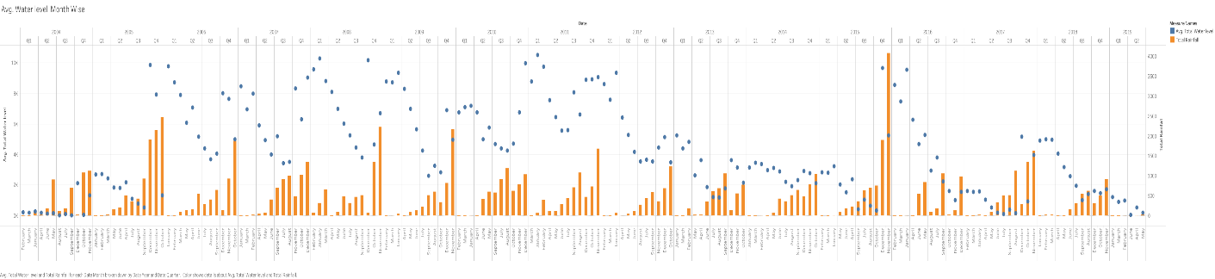

## What is probability that rainfall will be below average in the year 2019?

The probability of rain below average = 8/15 = 0.5333

## Water Level forecast:

**Inputs for Clustering**

Variables: Avg. Chembarambakkam

Avg. Cholavaram

Avg. Total Water level

Avg. Poondi

Avg. Redhills

Level of Detail: Year of Date

Scaling: Normalized

Summary Diagnostics

Number of Clusters: 2

Number of Points: 16

Between-group Sum of Squares: 5.8518

Within-group Sum of Squares: 1.8281

Total Sum of Squares: 7.6799

Centers

Clusters Number of Items Avg. Chembarambakkam Avg. Cholavaram Avg. Total Water Level Avg. Poondi Avg. Redhills

Cluster 1 9 0.28627 0.15122 0.25889 0.18312 0.33813

Cluster 2 7 0.79292 0.73417 0.79996 0.7742 0.83564

## Rainfall prediction for 2020 and 2021:

There has been decline in rainfall (below average = 5,517 mm) in the year 2016 and 2018 compared to previous years which led to water crisis in the year 2019. It is estimated to be average rainfall for the year 2019 and 2020 with 95% confidence.

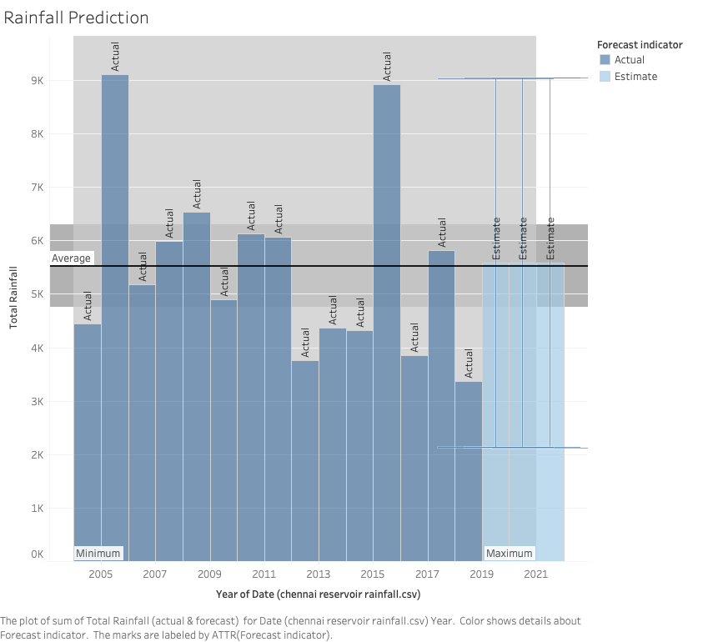

## 

# Section 4: Conclusion

With the analysis of the data for water level and rainfall, it can be concluded that

1. water levels of the reservoirs are depleting year by year basis.
2. Water consumption is increasing every year and the rainfall alone is not enough to increase the water level to the desired percentage.
3. The increased scope of Chennai Municipal corporation after year 2011 has put the water resources under more strain and level is not increasing with the same amount it used to before.
4. Current water level (17-Jun-2019) is only 26 mcft. If we assume that city is dependent on only these 4 reservoirs, then the water supply need of the Chennai city (approx. 230 mcft) cannot be meet unless some drastic rainfall happens.